The model to optimize the eradication of Ebola
Abstract 摘要:
Ebola, the deadly hemorrhagic fever, was first discovered in 1976, and it has haunted the public imagination for twenty years. Since December 2013, an ongoing outbreak of Ebola in West Africahas infected at more than 200 thousands people in Guinea, Sierra Leone and Liberia, including more than 80 thousands who died, according to the World Health Organization. The outbreak appears to be the largest in history and harm to people’s life and property.

......还没写......

In the process of Ebola spreading, the WHO(World Health Organization) publish epidemic information which offered good bases to our model and analysis.
Key words 关键词: Ebola; Infectious disease; Forecast;

Contents 目录
- Introduction & Backgrounds
介绍和背景...................................................................................................................................................3
  - What is Ebola?............................………………………….…………………….3
  - The history of Ebola outbreak.…………………………………………….……3
  - The prevention & control....…………………….…..…….…………………….3
  - The treatment & vaccine.....……………...……………………………………...3
- The Description of Problem（Problem Analysis）
问题重述（问题分析）….............................................................................................................5
  - Model 1: model of the spread of Ebola disease ..............................................................5
  - Model 2: model of ........................…………….………….5
  - Model 3: model of …………………………..……………….…6
- Models
模型……………...........................................................................................................................................7
  - Basic Model
基础模型.............................................................................................................................................7
    - Symbols and Definitions
符号和定义………………………………..…...……………………………...7
    - Assumptions
假设……………………………………………………………….……..……………..8
    - The Foundation of Model
模型的基础………………………………………………………………….9
    - Solution and Result
解决方案和结果……………………………………………………………….………...11
    - Analysis of the Result
结果分析……………………………………………….………………………..……….….11
    - Strength and Weakness
优点和缺点………………………………………………….…………….…..13
  - Improved Model
模型优化.................................................................................................14
    - Extra Symbols
其他符号……………………………………..………………………...…………………......................14
    - Additional Assumptions
附加假设………………………………………………...…..…………………………..14
    - The Foundation of Model
模型的基础………………………………..…………………………………………….14
    - Solution and Result
解决方案和结果………………………………………….……………………………..……………...15
    - Analysis of the Result
结果分析…………………………………………….……………………..…………….….18
    - Strength and Weakness
优点和缺点……………………………………………….……………….…..19
- Conclusions
结论..................................................................................................................................................19
  - Conclusions of the problem
问题的结论……………………………………..……………..19
  - Methods used in our models
用于我们模型的方法…………………………………...……………………..…………19
  - Application of our models
我们的模型的应用…………………………………………………..………………..….19
- Future Work
未来的工作..............................................................................................................................................19
  - Another model
其他模型………………………………………………………………………………………19
  - Another layout of toll plaza
收费中心的另一种布局………………………………………………………..……………23
  - The newly- adopted charging methods
新采用的装料方式………………………………………..……………23
- References
参考文献...................................................................................................................................................23
- Appendix
附录......................................................................................................................................................23
Programs and codes
程序和代码………………………………………………………………..……………………24
I. Introduction & Backgrounds 介绍和背景
姜启源传染病模型第一段开头几句
In order to indicate the origin of the Ebola virus problem, the following background is worth mentioning. 为了指出收费公路问题的起源，下面的背景值得一提。
1.1 What is Ebola?
Ebola is a very rare virus which is fund at Ebola rive area in southern Sudan and Congo in 1976 and that is why we called it “Ebola”. It is a deadly infectious virus which can cause Ebola hemorrhagic fever(EBHF: the most deadly viral hemorrhagic fever in the world) on humans and primates. The infected person have some symptom like nausea, vomiting, diarrhea and skin color changes etc. Ebola have high death rate from 50% to 90% and the cause of death mostly are stroke, myocardial infarction, low blood volume shock and multiple organ failure.
1.2 The history of Ebola outbreak
In 1976, Ebola firstly appeared in northern Congo, infected and killed many people in 55 village. After 3 years, it appeared in Sudan and killed many people too. But after 1979, Ebola disappeared 15 years and appeared again until 1994.
The outbreak appears recently to be the largest in history.Since December 2013, an ongoing outbreak of Ebola in West Africa has infected at more than 20 thousands people in Guinea, Sierra Leone and Liberia, including more than 8 thousands who died, except 15 dead come form other region, according to the World Health Organization.(WHO) The number of cases and deaths in this outbreak is more than the sum of other epidemic and the outbreak are still appearing among countries.
1.3 The prevention and control
The WHO and some dangerous countries take various measures to control the outbreak include supporting surveillance, community participation, case management, laboratory services, contactees tracing, infection control, logistical support and training and helping to safe burial. And all the measures are worked more all less. However this outbreak of Ebola virus disease is very serious even other regions except Guinea, Sierra Leone and Liberia have been appeared cases, it has aroused concern all around the world. Many countries including USA, japan and China begin to take some preventive measures and built Ebola laboratory for curing research one after another. And it is also have some progress.
1.4 The treatment and vaccine
As to Ebola virus, there is no proven treatment. But the world medical association(WMA) has been evaluating various possible treatments including blood products, immunization therapy and medicine therapy. Recently, the WMA has announced that their new medication could stop Ebola and cure patients whose disease is not advanced.
姜启源传染病模型第一段最后几句
Now the problem is whether the medication can eradicate Ebola or how the medication can relive current strain of Ebola.
II. The Description of the Problem（Problem Analysis） 问题重述（问题分析）
The question tolled us the world medical association has announced that their new medication could stop Ebola and cure patients whose disease is not advanced. Ans ask us to build a realistic, sensible, and useful model that considers not only the spread of the disease, the quantity of the medicine needed, possible feasible delivery systems, locations of delivery, speed of manufacturing of the vaccine or drug, but also any other critical factors we considers necessary as part of the model to optimize the eradication of Ebola, or at least its current strain. Consider the five factors the problem given, we decided to built two models to analyze.
2.1 Model 1: model of the spread of Ebola disease
In model 1, we built a SIR model to analyze the spread of Ebola disease. Like the common SIR model, we divided persons into three categories: S(susceptible), I(infected), And R(removal). We assumed that there are no treatment to cure Ebola patients therefore the “removal” is just the dead persons. We use the data of Guinea, Sierra Leone and Liberia offered by WHO to get and . And then we use MATLAB programming calculate the SIR equation
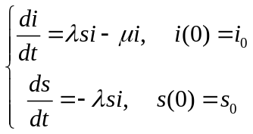
to get the numerical solution and trend chart of the three countries. By analyze one of the three countries’ result and figures, we get summarize at the last.
2.2
2.3
III. Models 模型
3.1 Basic Model 基础模型
3.1.1 Terms, Definitions and Symbols 术语，定义和符号(最后写)
The signs and definitions are mostly generated from SIR model. 符号的定义大多来自

3.1.2 Assumptions 假设
- WHO提供的全国疫情统计真实可信。
- We consider the statistical data of national epidemic offered by the World Health Organization(WHO) is authentic.
- 将Ebola所有可能的传播途径都视为与病源的直接接触。
- We consider Ebola virus infected people only by touch.
- 在疾病传播期内所考察的地区的总人数N视为常数。
- We set the headcount  is constant in investigated region when the diseases are spreading.
- 设每个病人每天有效接触的人数(所谓“有效接触”是指病人与健康者接触时,足以使健康者受到感染而成为病人)可视为常数。
- We set the quantity of persons that every patient contact per day effectively (which means the healthy people must be infected when contact with patient) is constant.
- 根据资料可知未出现症状的感染Ebola的人处于潜伏期并且不具有传染性。
- We consider the Ebola infected person who doesn’t appear symptom is in incubation period and have no infectious.
- 假设一个Ebola康复者二度感染Ebola的概率为0，这些人归为“退出者”。
- We assume that the Ebola survivors hardly infected Ebola and infectious ration is 0%. And we set these people are “removal(R)”.
- 被隔离的人群完全断绝与外界的接触,不再具有传染性
- We consider the segregated patients absolutely can’t contact with people outside and have no infectious any more.
- 弄清Ebola的传播特点需要相当多的病理知识，这里不可能从医学角度一一分析，而只是按照一般的传播机理建立模型。
- We need much more pathological knowledge to understand the spread characters of Ebola disease, but we can’t analyze it from medical purposes detailedly. We just built models according to general mechanism of transmission.
- We assumed that the one medicine can cure one people immediately. It’s means we don’t consider the time of curing.
3.1.3 The Foundation of Model 模型的基础
SIR model is the most classic one in epidemic models. It can describe the spreading progress of infectious virus, analyze change law of number of infected persons, forecast the time when the high tide of infectious disease is coming, measure the spreading degree of infectious disease and explore the treatment for stop spread.
In SIR model, people in infectious diseases range be divided into three categories: S(susceptible) is person who are uninfected but luck of immunity.which means it’s easy to be infected when attached the infected people; I(infected) is person who are infected and can infect the susceptible; And R(removal) is person who are be insulated or have immunity after recovery.
In SIR model, there is a assumption that the headcount is constant in investigated region when the diseases are spreading, which means it doesn’t consider birth or death and migration. And there are some definition below:
- At time, the proportions of three types of people in headcount respectively be write for 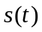, 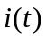 and 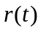.
- The contact rate per day is . The cure rate per day is 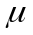. And the number of contact in infectious period is 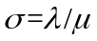.
According to the assumption, we can obviously get:
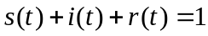（1）
Every patient can infected 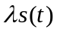 healthy people per day. The number of patients is 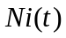, so we can get there are 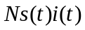 healthy people be infected. Therefore the 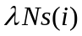 is the increasing rate of 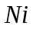 that the number of patients. From define (2), we can obviously get the 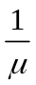 is average infectious period of this infectious disease. And we can easily get the function:
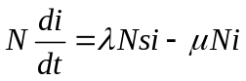（2）
Therefore, for the removal(R) we have:
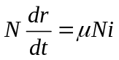（3）
And we set the ration of susceptible(s) and infected(I) at the first respectively are 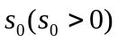 and 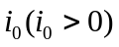(and set the original value of removal(R) is 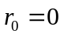 as well). Therefore, from (1), (2) and (3), we have the junction of SIR model:
（4）
We can use MATLAB to programming for numerical value calculation and get analytic solution of equations below. And then we can observe the figures and do some theoretical analysis to get conclusion.
3.1.4 Solution and Result 解决方案和结果
- Solutions
Model 1: The solution of the SIR SIR的解决方案:
本模型近似于经典的S-I-R模型。S(susceptible)是易感人群，I(Infected)是已感染人群，R(Recovered)是移出的人群。Cause we assume Ebola can not be cured, so the infected(I) just have only way to be removal(R)-dead. 感染人群有一定几率传染易感人群，使其转变成为感染人群。而感染人群也可能dead and become removal(R)。感染的强度和恢复天数的长短可以由参数控制。
Our model is similar to classical S-I-R model. S(susceptible) is person who can easily be infected Ebola virus, I(infected) is person have been infected and R(removal) is person who have been moving out. Cause we assume Ebola can not be cured, so the infected(I) just have only way to be removal(R)-dead. The infected(I) people have some probability that it can infect the susceptible(S) people and made them to be infected(I). But the infected(I) can also dead and become removal(R) people. The strength of the infection can be control by parameters.
There are some settings below:
- The headcount is constant in investigated region when the diseases are spreading.
- people in infectious diseases range be divided into three categories: S(susceptible), I(infected) And R(removal).
- At time, the proportions of three types of people in headcount respectively be write for , and .
- The contact rate per day is . The cure rate per day is . And the number of contact in infectious period is .
在一段时间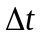内建立方程：
And then we set up equations Over a period of time . Firstly, the ratio of S, I and R have relationship like:
病人、健康人和移出者比例之和为1：
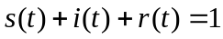（1）
And in a week, the quantity of new increased cases is:
在一周内新增的病例数为：
（2）
健康人减少的人数等于被已感染的人传染的人数：
And the quantity of reduced S is equal to the quantity of persons who have been infected. We have:
（3）
And we set the ration of susceptible(s) and infected(I) at the first respectively are and (and set the original value of removal(R) is as well). Therefor, from (1), (2) and (3), we have the junction of Ebola SIR model:

上述方程组用微分方程组表示如下：To sum up, we get:
()
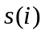, 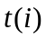的求解极度困难，在此我们先做数值计算来预估计, 的一般变化规律。
, can hardly to be solved, so we estimated the general change law of , by numerical calculation.
根据方程（4）和最新的WHO统计报告，分别计算3个国家的人口中患病人数和健康人数的比列。
According to equation and the latest statistical report of WHO, we calculated the ration of infected people and susceptible people in the three countries.
Firstly, according to the statistical data of Liberia of WHO, 根据WTO在Liberia的统计数据, we chose the data from 2014.03.25 to 2014.02.04:
Table The statistical of WHO of Liberia
WHO report date | Total Cases | Total Deaths | Daily contact rate | Daily remove rate
2014/3/25 | 0 | 0
2014/4/1 | 8 | 2 | 1.75 | 0.545454545
2014/4/10 | 22 | 14 | 0.227272727 | -0.037037037
... ... | ... ... | ... ... | ... ... | ... ...
2015/1/21 | 8478 | 3605 | 0.016985138 | 0.009394572
2015/1/28 | 8622 | 3686 | 0.014265832 | 0.006861063
2015/2/4 | 8745 | 3746
Population | 11200000 | Average | 0.235660447 | 0.074676766

我们计算得到
And we get:
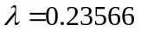, 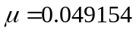
We set 2015.02.04 is the initial day of our simulation. 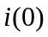 is total cases divided by population of Guinea. Therefor we have:
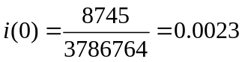
and
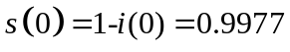
我们用matlab计算他们的数值解。输出的简明计算结果列入表1，We use MATLAB to programming for numerical value calculation and get simple calculate results put in We use MATLAB to programming for numerical value calculation and get simple calculate results put in Table 1, Table 1, 并得到Liberia健康人数和患病人数的走势图如下图1,2所示, and figures of , shown in Figure 1 and Figure 2:
Table the value calculation of and of Liberia
 | 0 | 1 | 2 | 3 | 4 | 5 | 6 | 7 | 8
 | 0.00230936 | 0.002711067 | 0.003182281 | 0.00373464 | 0.004381828 | 0.005139985 | 0.006027715 | 0.007066538 | 0.008281039
 | 0.99769064 | 0.997101877 | 0.996411028 | 0.995600932 | 0.994651382 | 0.993538473 | 0.99223461 | 0.990707774 | 0.988921361
 | 9 | 10 | 15 | 20 | 25 | 30 | 35 | 40 | 45
 | 0.009699641 | 0.011355277 | 0.024681507 | 0.05183398 | 0.101681203 | 0.176914563 | 0.258710786 | 0.311254622 | 0.316200518
 | 0.986832858 | 0.98439272 | 0.964645081 | 0.92377444 | 0.846093836 | 0.719503716 | 0.556038086 | 0.395697069 | 0.272181825

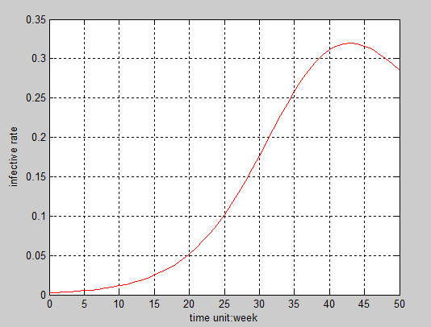
图1 The ration of I of Liberia患病人数比例
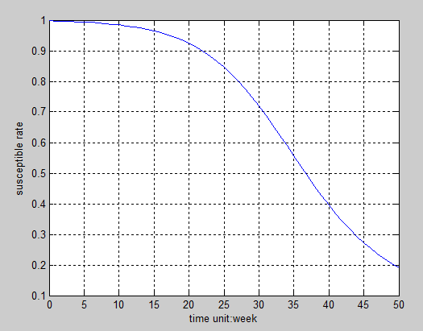
图2 The ration of S of Liberia健康人数比列
And then we can observe the figures and do some theoretical analysis to get conclusion. From figures , we can see the of Liberia increase firstly until about 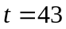 when it is maximum and then it began to decrease, 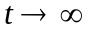, 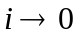. And are monotone decreasing, , 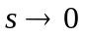.
We also get the 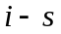 orbit which is phase trajectories shown in Figure :
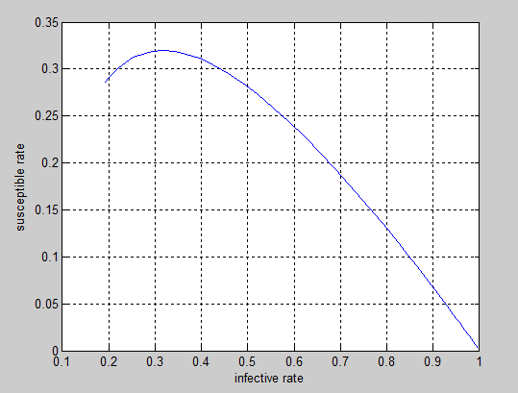
Figure the orbit of Liberia
The coordinate point 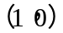 is initial value 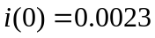, 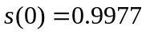. The 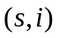 ratio move with the increasing of from right to left.
We get the character of and based on value calculation and figures observing:
- Whatever the value of 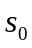 and , the patients will be disappeared at the end.
- The ration of healthy persons tend to stability at the end.
Similarly, we get information of Guinea and Sierra by calculated.同理我们分别计算得到Guinea和Sierra Leone的数据, And the figures shown in Figure and Figure .
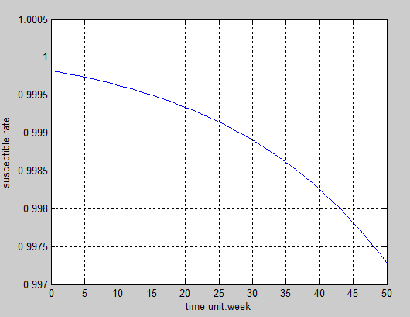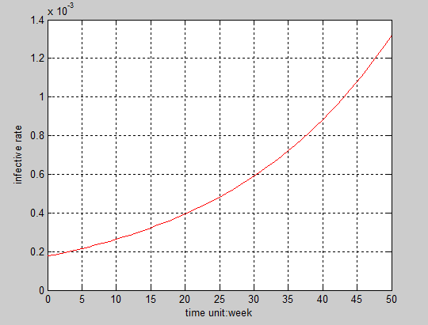
Figure The ration of S of Guinea Figure The ration of I of Guinea
健康人比例 患病人数所占比例
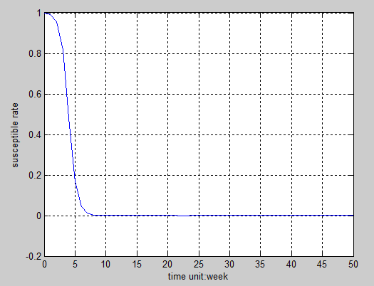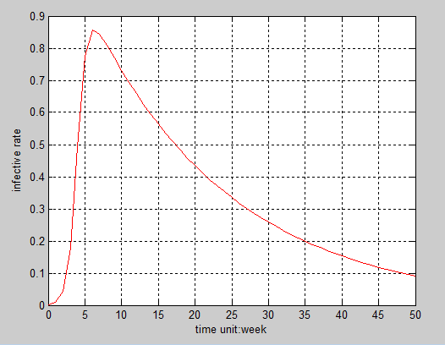
Figure The ration of S of Sierra Leone Figure The ration of I of Sierra Leone
健康人比例 病人数比例
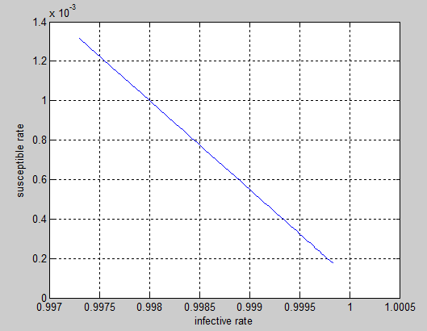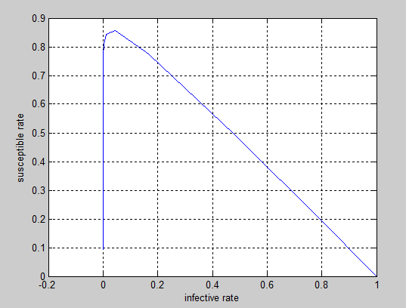
Figure the orbit of Guinea Figure the orbit of Sierra Leone
According to all the information from these figures above, we can see the situation is not optimistic. On the one hand we assumed there no treatment to sure the diseases. On the other hand the value of and are approximations. If like the question says that the WMO find a new medication could stop Ebola and cure patients whose disease is not advanced, there would be batter in fact.
Model 2:
在第一问我们对未来患病人数和健康人数的比列of three countries进行了预测，and now we solve the quantity of the medicine needed and seed of manufacturing of the vaccine or drug.
In model one, we assumed have no medicine to use and forecast the ratio of I and S of three countries. Now we solve the quantity of the medicine needed and seed of manufacturing of the vaccine or drug.
在计算需求量of the medicine和生产速度 of the vaccine or drug的过程中，由于我们开始使用medicine对患病人们进行治疗，因此第一问的模型中的移出率要增加治愈人数所占的比例即治愈率. 我们以周为单位，therefore每周的治愈率在发生变化，每周的患病人数也在发生变化. 每当我们计算下一周的时候就要用上一周新的数据进行计算。
When we calculate the quantity of medicine needed and speed of manufacturing the medicine, the assumption that there are no treatment to cure Ebola of model 1 don’t worked. Now we should consider the quantity of patients weekly under the situation that the Ebola can be cured. Therefore, the ratio of R in model 1 should add the ratio of survival who be cured by the medicine. Our unit is week, therefore the survival ration is changed every week and also the quantity of patient. We should use the new data of last week when we calculate this week’s data.
我们借助matlab通过数值仿真计算模拟，we get, 如果要能够在最后完全治愈疾病，则三个国家药物生产速度应该分别is:
We use MATALB programming to do some numerical simulation calculations and dynamic simulation. And we get the internal of speed of manufacturing of the medicine (shown in Table ) if the three countries want to wipe out Ebola diseases.
Table the speed of manufacturing of the medicine
 | Minimum | Maximum | Step
Guinea | 60 | 1000 | 20
Sierra Leone | 1800 | 2400 | 20
Liberia | 2000 | 3000 | 20
在此区间内我们取步长为5计算药物需要持续供应多少天才能完全治好所有患者。
In this internal, we set step size is 5 to calculate how many days should the medicine supply persistently can cure all the patients.
由题可知药物只能治愈早前患者，因此我们假设the patients whose disease is not advanced are accounted for 90% of total patients. It meas that在接受药物治疗的患者当中，有90%的人能够痊愈，we 借助matlab计算得到数据in Table and the speed of manufacturing of the medicine of几内亚和彻底治疗天数关系shown in Figure .
According to the question, the medicine only cure the Ebola patients whose disease is not advanced. So the assumed that the patients whose disease is not advanced are accounted for 90% of total patients. It is means the well-healed persons accounted for 90% of people who take the treatment by the medicine. We also use MATLAB to calculate and get the data(shown in Table ). And the relationship of speed of manufacturing of the medicine and the quantity of days that needed to cure the patient totally in Guinea
Table . The speed of manufacturing of the medicine and weeks deeded of Guinea
Speed | 140 | 160 | 180 | 200 | 220 | 240 | 260 | 280
Weeks | 28 | 22 | 19 | 16 | 14 | 13 | 11 | 10
Speed | 300-320 | 340-360 | 380-400 | 420-460 | 480-540 | 560-680 | 700-880 | 900-1000
Weeks | 9 | 8 | 7 | 6 | 5 | 4 | 3 | 2

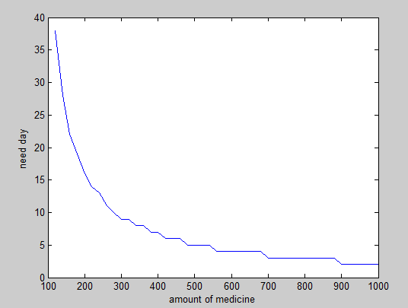(图标横坐标应该是速度)
Figure . the relationship of speed of manufacturing of the medicine and the quantity of days that needed to cure the patient totally in Guinea
从图中我们可以看出，当药物生产数量a week增加时，完全治疗所需要的天数也在不断的减小。当我们每周生产的药物数量不一样时，总需求量也是不一样的，其总需要量=周供应量*持续供应时间。而由表中数据我们得到所需药物总量和生产速度的关系图如csa
According to Figure we can see that the quantity of weeks of needed to cure all the patients reduce constantly with the increasing of the quantity of manufacturing of the medicines weekly. And we set:
Therefor, different quantity of the manufacturing of the medicine weekly corresponds to different total quantity needed.
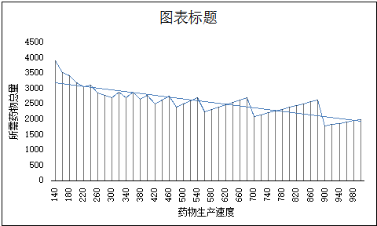
Figure . The relationship of speed of manufacturing weekly and total quantity of the medicine in Guinea.
从图中趋势线我们可以看出，当生产药物数量a week增加，所需药物总量almost是在逐渐减少的, 当药物生产速度在900左右的时候，所需药物的总数最小。并且完全治愈的天数也很小。因此在实际生产的过程中，应该向这个值逼近。So the WMO should manufacture about 900 units medicines a week in order to eradicating Ebola in Guinea.
According to the trend line in Figure we can see that the total quantity of the medicine needed almost reduce with the increasing of the quantity of manufacturing per week. When the speed of manufacturing are getting about 900, the total quantity of the medicine needed is the least and the quantity of weeks needed to cure all the patients also very less at the same time. Therefore the quantity of manufacturing of the medicine should be close to the speed value mentioned above. It ‘s means the WMO(or the manufacture) should manufacture about 900 units medicines a week in order to eradicating Ebola in Guinea.
同理可得利比里亚的数据（见表格和关系图）：
The same procedure may be easily adapted to obtain data of Liberia and Sierra Leone. Shown in Table and Figure :
Table . The speed of manufacturing of the medicine and weeks deeded of Liberia
Speed | 1840 | 1860 | 1880 | 1900 | 1920 | 1940 | 1960 | 1980
Weeks | 34 | 27 | 24 | 22 | 20 | 19 | 18 | 17
Speed | 2000-2020 | 2040-2060 | 2080-2100 | 2120-2140 | 2160-2220 | 2240-2280 | 2300-2380 | 2400
Weeks | 16 | 15 | 14 | 13 | 12 | 11 | 10 | 9

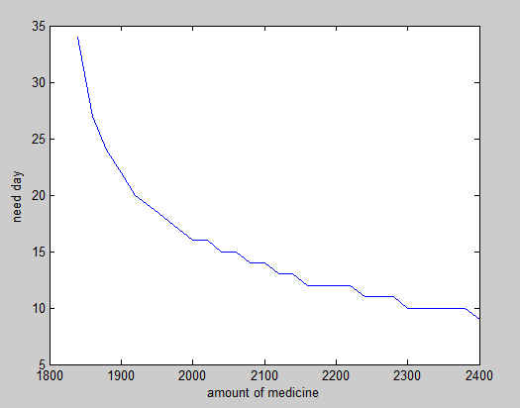
Figure . the relationship of speed of manufacturing of the medicine and the quantity of days that needed to cure the patient totally in Liberia

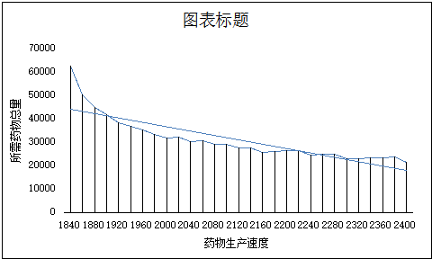
Figure . The relationship of speed of manufacturing weekly and total quantity of the medicine in Liberia.

According to Figure we can see the WMO should manufacture about 2400 units medicines a week in order to eradicating Ebola in Liberia.

Table . The speed of manufacturing of the medicine and weeks deeded of Sierra Leone
Speed | 2260 | 2280 | 2300 | 2320 | 2340 | 2360
Weeks | 35 | 28 | 25 | 23 | 22 | 20
Speed | 2380 | 2400-2420 | 2440 | 2460-2480 | 2500-2520 | 2540-2580
Weeks | 19 | 18 | 17 | 16 | 15 | 14
Speed | 2600-2640 | 2660-2720 | 2740-2820 | 2840-2940 | 2960-3000
Weeks | 13 | 12 | 11 | 10 | 9

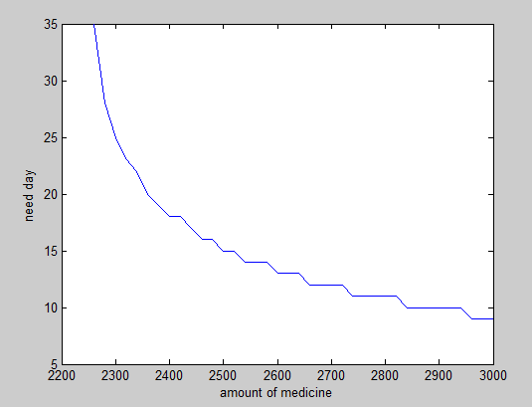
Figure . the relationship of speed of manufacturing of the medicine and the quantity of days that needed to cure the patient totally in Sierra Leone
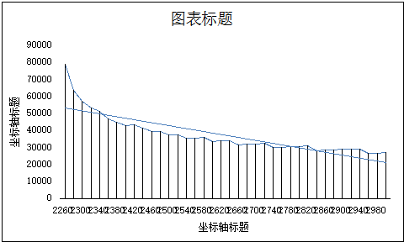
(横纵坐标标注)
Figure . The relationship of speed of manufacturing weekly and total quantity of the medicine in Sierra Leone.

According to Figure we can see the WMO should manufacture about 2980 units medicines a week in order to eradicating Ebola in Sierra Leone.

由以上数据我们可以得到，三个国家苏需药物总量和其相对应的生产速度，而所需药物的总量为三个国家的总和，shown in table
But above all, we can get data of the Speed of manufacturing of medicine(per week), Quantity of the medicine needed (unit) and weeks needed of the three countries and the total quantity. Shown in table
Table the Speed of manufacturing of medicine and Quantity of the medicine needed of three countries
 | Speed of manufacturing of medicine  (per week) | Quantity of the medicine needed  (unit)
Guinea | 900 | 1800
Liberia | 2400 | 21600
Sierra Leone | 2980 | 26820
Total | 6280 | 50220

Model3: The analysis of delivery systems and locations
模型一：救助中心的救助范围确定问题
The problem of scope of relief in the assistance center
通过该模型我们可以确定每个救助中心分别对那些灾区（疾病爆发点）进行管理，从而使整个调度的工作压力最小。
According to the model, we could find the outbreak of the epidemic point that rescue center management, so make the pressure of the whole dispatch is smallest.
模型约束
0-1variable constraint xij is : Article I a rescue center whether 0-1 variable management article J in the disaster area
1.0-1变量约束.xij为第i个救助中心是否管理第j个灾区的0-1变量，即是
Xij属于{0，1}。
At each disaster area must be the constraints. Requirements of each disaster area at least one rescue center management
2.每个灾区都必须被管理的约束。要求每一个灾区至少有一个救助中心管理，即
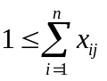
Considering the rescue center of pressure, we require each rescue center at most 4 disaster management
3.考虑到救助中心的压力，我们要求每个救助中心最多管理4个灾区，即为
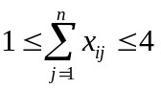
模型建立
The establishment of various rescue center workload variance least squares rule model
建立各个救助中心工作量方差最小二乘法规则模型（Aj表示第j个灾区的患病人数）
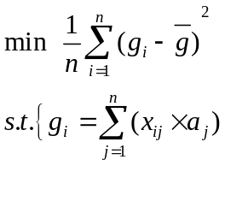
。。。。。

This model uses the method of multi goal programming This model uses the method of multi goal programming. In the workload of the largest, platform working pressure minimum, so that the workload distribution as far as possible the balance situation. We can determinethe drug should be put into those rescue center. Through the model calculated scheme can improve the utilization rate of the rescue center, the average distribution of working strength across platforms.

模型二：投放运输模型
本模型采用多目标规划的方法，在工作量最大，平台工作压力最小，使工作量的分配尽可能的平衡的境况下，我们可以确定药物应该投放到那些救助中心，分发到药物的救助中心又应该分别把药物分发到那些救助中心。通过本模型求出来的方案可以提高救助中心的利用率，平均的分配了各平台之间的工作强度。
第一层目标函数：(还没写完)

- Results 结果:
Model 1:
According to the model 1 we built, we can see the spread of Ebola diseases in Liberia, Guinea and Sierra Leone.
Since we assumed the total population is constant and the removal(R) is just the dead people, we get the simulation curves of (susceptible), (infected) and (removal). At firstly, the quantity of infected people is increasing and when it arrive some top point the curves begin to decline, it means that the quantity is reducing. But the susceptible people are always reducing because the total population is not change and healthy people be infected and dead constantly. But the ration of infectious is less than death’s, the infected persons will be disappeared and the quantity of susceptible people will tend to be stable.
Model 2:
According to the data we get above , we can see the result is batter than model 1 because we add the ration of survival to the ration of removal(R). And the faster the medicine manufactured, the faster the epidemic can be control. But we just consider the quantity of medicine that manufactured in one week as the speed of manufacturing of medicine and ignore the manufactural time , the transportation time, the time start from the patient take the medicine treatment to it worked, and any other factors. Therefore the trend chart of relationship of speed of manufacturing of the medicine and the quantity of days that needed to cure the patient totally is simplex and absolute. If consider all the factors, the quantity of days that needed to cure the patient totally would not tend to be zero when the speed of manufacturing of medicine is tend to be infinity, which we all know that is impossible. When the speed of manufacturing achieve a value, the quantity of days that needed will be reduced slowly and close to a constant. Because we just analysis the reasonable quantity and speed of manufacturing of medicine needed, and we get the conclusion that the use of medicine do stop the Ebola is satisfactory.
3.1.5 Analysis of the Result 结果分析
- Sensitivity 灵敏度:
Model 1:
We analyzed the sensitivity of in model 1 by change the value of .
We increased and reduced 5% accounts of value on respectively, and put it in the SIR equation. The results calculated by MATLAB shown in table :
Table
Liberia | 1 | 0.284836494 | 0.19053791 | 0.525614836
Liberia | 1.05 | 0.272787673 | 0.14486371 | 0.583337857
Liberia | 0.95 | 0.288839867 | 0.251453639 | 0.460695734
Guinea | 1 | 0.284836494 | 0.19053791 | 0.525614836
Guinea | 1.05 | 0.272787673 | 0.14486371 | 0.583337857
Guinea | 0.95 | 0.288839867 | 0.251453639 | 0.460695734
Sierra Leone | 1 | 0.090980291 | 0.00000000003 | 0.909616869
Sierra Leone | 1.05 | 0.090043046 | 0.00000000002 | 0.910554114
Sierra Leone | 0.95 | 0.092032254 | 0.00000000004 | 0.908564906
According to the table , we can see under the situation that the error range of is 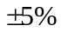, the change of , and is not obviously when the changed. Therefore we think the value of that we set is feasible.
Therefore we can see the result is not sensitive to the change of the parameter 结果对参数的变化不敏感

- Trend 趋势:
- Comparison 比较: （三个国家比较一下）
3.1.6 Strength and Weakness 优点和缺点
- Strength 优点:
- In despite of this, the model has proved that the spread of Ebola is very fact but controllable. 尽管如此，该模型已经证明了…
- Moreover, we have drawn some useful conclusions about how to control the spread of infectious disease like to isolate the patients or to inject vaccine to healthy people. 此外,我们得到了一些关于…有用的结论
- The model is fit for the prediction of spread of general infectious disease, such as dengue fever.模型对于…是合适的，例如…
- Under the situation that the error range of is , the change of , is not obviously when the changed.
- Weakness 缺点:
- This model just applies to serious infectious disease which hardly to be cured. 这个模型只适用于… As we have stated in model 1, Ebola can’t be cured. But actually, there are medicine can stop Ebola and cure patients whose disease is not advanced. And that’s just what we should do in the improved model. 这正是我们在模型改进里应该做的
- In model 1, we assumed there are no treatment can cure Ebola patients, it’s unrealistic. The WMO has announced that their new medication could stop Ebola and cure patients whose disease is not advanced. Therefor our model should consider the factors of Ebola survivors and get batter results. But the data we found is not sufficient and there are few cases that Ebola patients be cured. We just consider the simple situation that have no treatment.
3.2 Improved Model 模型优化
3.2.1 Extra Symbols 其他符号
Signs and definitions indicated above are still valid. Here are some extra signs and definitions. 上诉的符号和定义仍然有效，这里有一些额外的符号和定义。

3.2.2 Additional Assumptions 附加假设
Assumptions concerning the anterior process are the same as the Basic Model. 假设关于前过程的处理和基本模型一样。
3.2.3 The Foundation of Model 模型的基础
As we have concluded from the Basic Model, 正如我们从基础模型中得到的结论…
3.2.4 Solution and Result 解决方案和结果
Based on model 1, we built another model that more reality.
因为在Ebola流行的过程中，各个国家都采取了一定的措施，大部分国家都采取了隔离的制度，所以在模型一的基础上，考虑到隔离人数比例G和未隔离人数比例W，还有接触过发病后没有及时隔离治疗的人的人数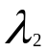 ，我们建立了改进的模型，方程组如下：
Cause in the spreading of Ebola disease, every country have takes actions to some extent. Most of countries adopted the isolation system. Therefore, we consider ont only the ration of quantity of people who is isolated and who isn’t. we set the ration is 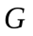 and  respectively, but also the quantity of people who have been infected Ebola patient but not isolated, we set the quantity is . And based on model 1, we improve our model and build a new model. The equations of the optimize model is:
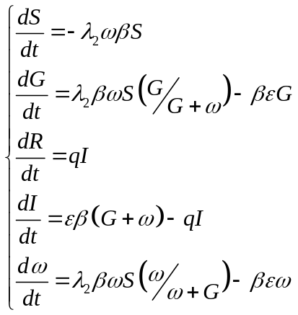
以上方程组的初值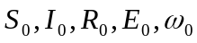分别代表各个字母代表的初值。
Where the 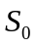, 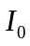, 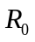, 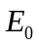 and 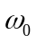 is the initial value of , , ,  and .
Obviously this mode is close to the actual situation mostly，but it has too much parameters which can hardly ensure. Therefore we don’t use this optimize model to resolve the Ebola problem.但由于这个模型设计的参数过多，数据难于确定，并不利于对Ebola的传播流行进行分析。所以采用模型一进行分析求解，试图找出Ebola传播的规律的特点。
3.2.5 Strength and Weakness 优点和缺点
- Strength 优点: The Improved Model aims to make up for the neglect of people who is isolated and who isn’t. 改进后的模型旨在弥补对…的忽视Although we can’t solve this model. We believe the result will declare that this model is more reasonable than the Basic Model and much more effective than the existing design. 结果似乎表明这个模型比基本模型更合理，比现有的设计更有效。
- Weakness 缺点: Thus the model is still an approximate. 然而,这仍然是一个近似的模型。 This has doomed to limit the applications of it. 这注定要限制它的应用范围。
IV. Conclusions 结论
4.1 Conclusions of the problem 问题的结论

4.2 Methods used in our models用于我们模型的方法
- SIR

4.3 Applications of our models 我们的模型的应用

V. Future Work 未来的工作
5.1 Another model 其他模型
5.1.2
5.1.3
5.1.4
1)

2)

3)

4)
5.2
5.3
VI. References 参考文献
[1] Ebola virus(Fiber virus families, Ebola-like viruses)_Baidu Encyclopedia:
http://baike.baidu.com/link?url=R1JVQITL60PFUwzIPpxcLc4nXCM4E-J0QMYco9SjvhqPopZLILmn4mQy82m-L4n2uTIHxanqWXl04mELP3h987q5endV6N3xi8FnHMgNThJHfIf6X-yrgdWMcc0GASNaVDd_lcnoVwWBTmZgT3hvXFHT4ASLOg34rKp7wIDl_hBEfERxtlHqDIB6VC7NNIzx (6 February,2015).
[2] Ebola – Wikipedia: http://fi.wikipedia.org/wiki/Ebola (6 February, 2015).
[3] 2014 Certificate Authority Cup International Mathematical Contest in Modeling ICM c. http://mcm.tzmcm.cn/ (6 February, 2015).
[4] WHO | World Health Organization: http://www.who.int/en/ (6 February, 2015)
[5] S-I-R model_Baidu Encyclopedia: http://baike.baidu.com/view/10460829.htm (6 February, 2015).
[6] Jiang, Qiyuan. Mathematical model (Fourth edition)[M]. Higher Education Press, 2011. 136:145.
[7] Zhou Yichang, Tang Yun. Mathematical model to predict the spread of SARS[J]. Journal of Engineering Mathematics. Vol. 20, No. 7, Dec. 2003.
[8] 2014 Ebola Outbreak in West Africa - Reported Cases Graphs | Ebola Hemorrhagic Fever | CDC.
http://www.cdc.gov/vhf/ebola/outbreaks/2014-west-africa/cumulative-cases-graphs.html

Appendix 附录
Programs and codes 程序和代码

